REQUEST FOR QUOTATION

Date: 11th August 2022

From:
Norwegian Refugee Council (NRC)
Gedarif Area Office

Gadarif Office – East Jobarab – Alriyada Street - Gadarif Sudan
https://goo.gl/maps/ppyRwrzuUeCX6pVy6

Contact person: | Fatima Abdelgadir
Position: | Logistics Assistant
Email: | Sd.procurement@nrc.no and Ccfatima.abdelgadir@nrc.no
Phone: | +249 911219830

Deadline for submission: 24 August 2022 @ 12:00 PM

1 - NRC is looking for the following items, based on the below:

1-1- Tailoring

# | Description | Specification | Unit | Qty | Unit Cost in SDG or USD VAT Inclusive | Total cost in SDG or USD VAT Inclusive
1 | sewing machines | Small size manual sewing machine with table 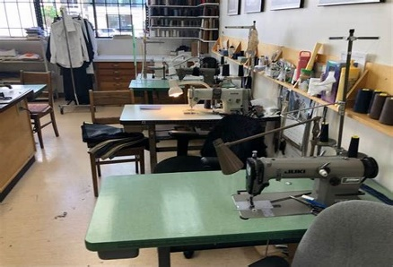 | Pcs | 10
2 | scissors | medium Size, iron | Pcs | 10
3 | large white yarn | 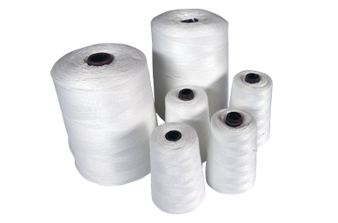 | Pcs | 20
4 | plan full cloth role (Different colors )mix plan and embraided budra fabric | 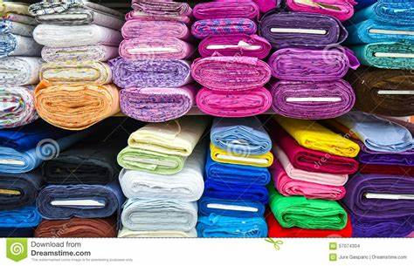 | Roll | 10
5 | tape for measure |  | Pcs | 10
6 | shirt buttons | Multiple sizes (black and white) | Dozen | 10
7 | zipers | small, medium and larg sizes | Dozen | 10
8 | needles | Big and medium size | Package | 10
9 | machine oil | To be used for the sewing machines | Box | 10
10 | sleeves designs, different colors and shaps ركامة مشكلة | 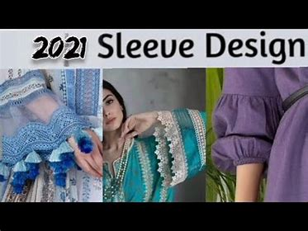 | Meter | 10
11 | sleeves desgins, black and white colors ركامة سادة | 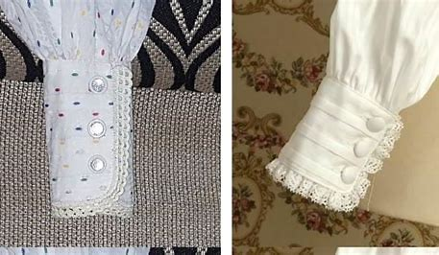 | Meter | 10
12 | Sewing Stones (decorations for clothes) كلف منوعة | Shiny and glittering stones to be sewn into clothing as decorations | Box | 24
13 | cristel waist belts different colors, Medium, small and larg sizes دعامة كرستال |  | Pcs | 10
14 | cube beads | 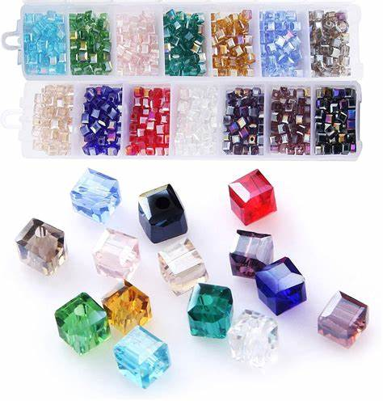 | Roll | 10
15 | nerve thread yarn خيط عصب | 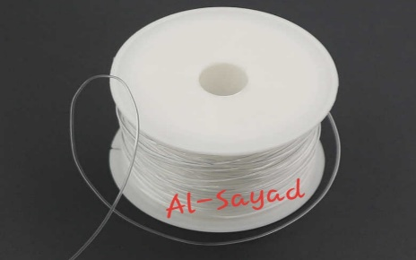 | Roll | 10
16 | cashmere yarn | 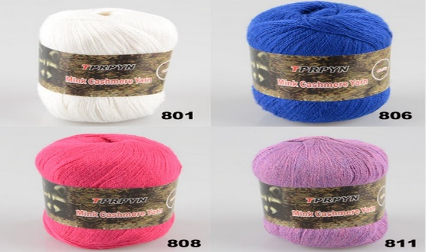  Different colors, big size | Roll | 10
17 | ودع ملون Colored beads | 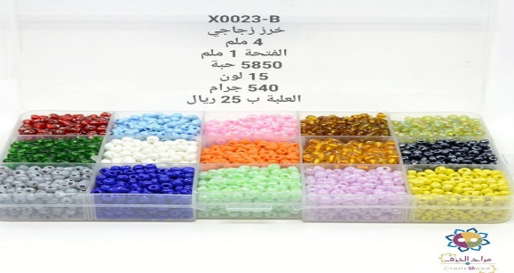 | Set | 5
18 | small scissors مقصات صغيرة | Small,metal | Pcs | 10
19 | توب لستك Waistband | Medium Size | Roll | 10
20 | Was pistol مسدس شمع | 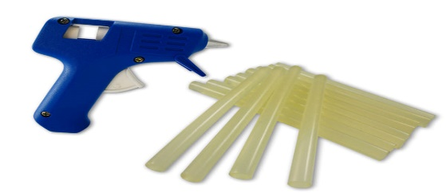 | Pcs | 10
21 | glue box for clothes | 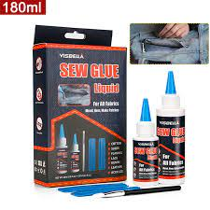 | Box | 5
22 | إبر كروشي Crochet needles | 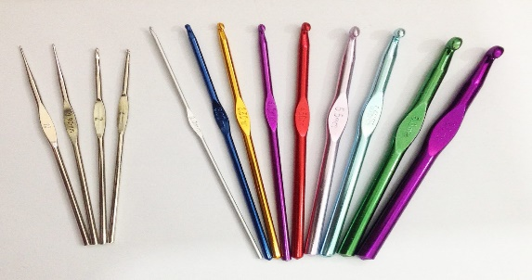 | Pcs | 10
23 | elastic grade thread | 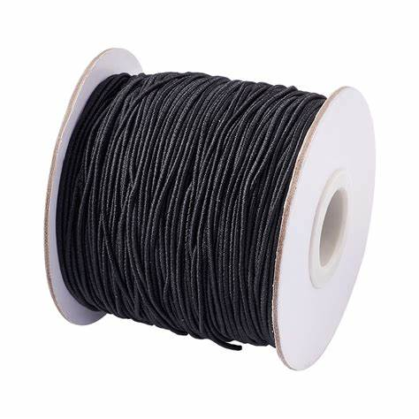 | Box | 2
24 | Steam Iron | Medium Size iron, high qulaity with larg water tank | Pcs | 3
25 | colorful Emproided cloth rolls | 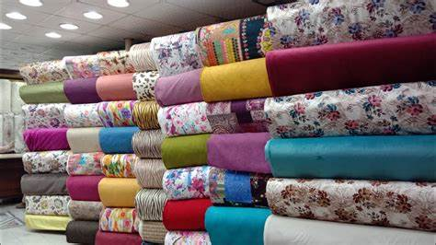 rolls of different colors | Roll | 10
Total Price VAT Inclusive

1-2- Poultry breeding

# | Items Description | QTY | Unit Cost in SDG or USD VAT Inclusive | Total cost in SDG or USD VAT Inclusive
1 | poultry shed square pipes, Zinc 12 feet, - Expenda, Cement, sand, construction cost | 1
2 | chicken-egg atpoint of fly , 50 chicken 16 weeks age, to be brought from khartoum | 50
3 | 100 forbroiler chicken, one day old | 100
4 | 6 sack of sorghum Sack | 6
5 | wheat husk(Radaa) Sack | 3
6 | Squeezed Groundnut leftover dough Sack | 2
7 | protein for chicken-egg, animal protein one Sack | 1
8 | protein forbroiler chicken, animal protein one Sack | 1
9 | Antitoxin, 1kg | 1
10 | Lysine, 1kg | 1
11 | Normal Salt | 3
12 | Seasheels to be used for feeding the chickens صدف | 2bags
13 | Anticoccidiosis1kg | 0.5
Total Price VAT Inclusive
1-3- Small Motors Department

# | Items | Specifications | Unit | QTY | Unit Cost in SDG or USD VAT Inclusive | Total cost in SDG or USD VAT Inclusive
1 | Hammer | Different weight |  | 4
2 | cut chisel | Different weight |  | 4
3 | drill | Different weight |  | 4
4 | Pliers | Larg size |  | 5
5 | pliers | Medium size 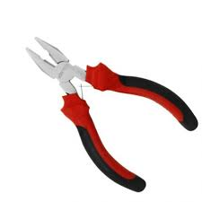 |  | 5
6 | Pliers | Small size |  | 5
7 | pliers | wire stripping 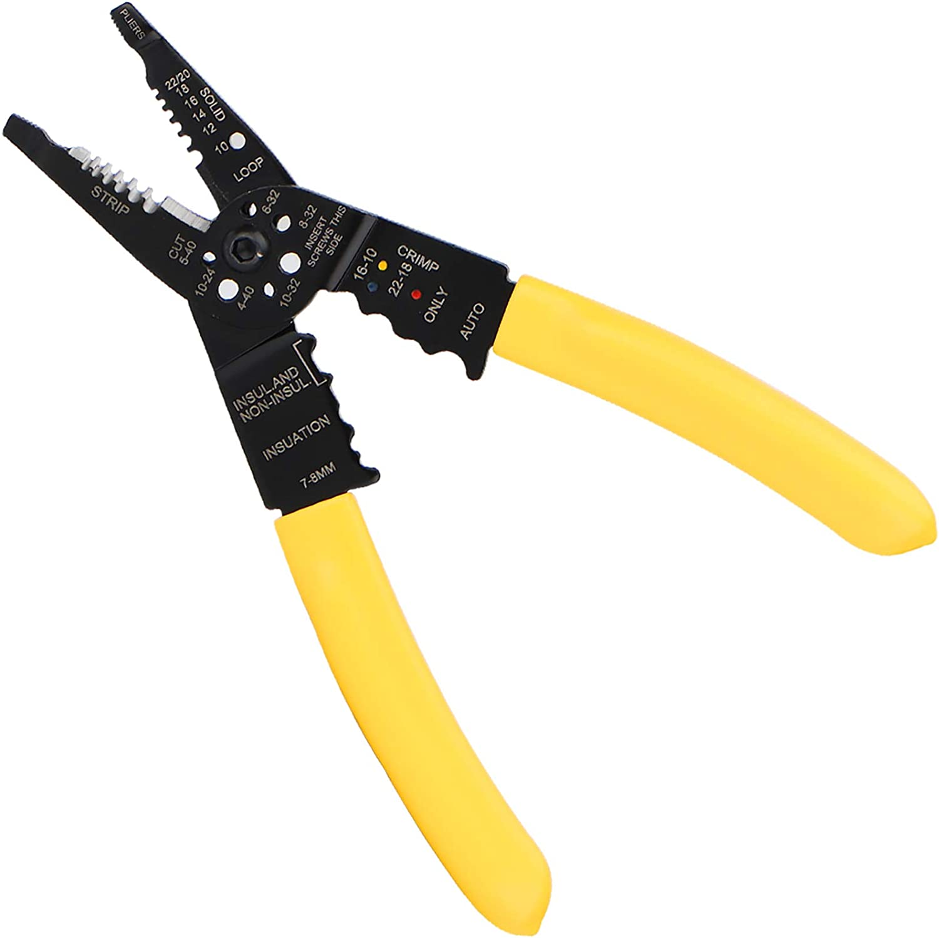 |  | 5
8 | pliers | نبل داخلية وخارجية internal / External |  | 5
9 | key set | normal | set | 1
10 | key set | standard | set | 1
11 | Tool Kitsشنطة حبوب | Big size | Kit | 1
12 | شنطة حبوب Tool Kits | Small size | Kit | 1
13 | Screwdriver set | Local screwdriver | set | 1
14 | Screwdriver set | Local screwdriver | set | 1
15 | Screwdriver set | Small size, star type | set | 1
16 | Screwdriver set | Big size, star type | set | 1
17 | Lanky key kit | Larg size | Kit | 2
18 | Lanky key kit | Small size | Kit | 2
19 | sandpaper | Rough and soft. |  | 4
20 | Wire cleaner brush | 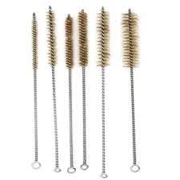 | Dozen | 4
21 | super Glue بوستك أوشاش |  | Pcs | 6
22 | lifting Jack عفريتة رفع | Small size | pcs | 3
23 | loading Blocks كتل تحميل | wooden blocks | Packet | 2
24 | جهاز أمبيرAmpere | Standered control box | box | 3
25 | Motorcycle موتر لستكين | Bagag ,boxer 150CC |  | 1
26 | tuk-tukتكتك |  |  | 1
27 | Accelerator Wires أسلاك أبنصي | Five for Motorcycle and five for tuk-tuk |  | 10
28 | Sickleمنجلة |  |  | 4
29 | Saw cutمنشار قطع | 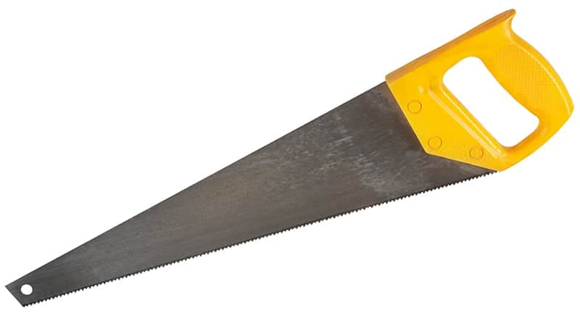 |  | 6
30 | Bearing Greaseشحم بلالي | 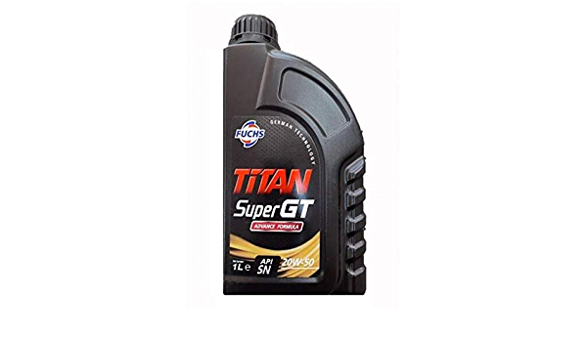 |  | 3
31 | Motor machineمكنة موتر | TwoBagag ,boxer 150CC | Pcs | 3
32 | tuk tuk machine مكنة تكتك | TwoTVS | pcs | 2
33 | soapصابون | Powder 10 kg, tide or similar | KG | 5
34 | soapصابون | Liquid ,5 liters teery or similar | Packet | 1
35 | towelفوطة | Damore Clothقماش دمورية | Meter | 50
36 | Washing basinحوض غسيل | Iron, mediuem size | Pcs | 4
37 | Benzine washingبنزين غسيل |  | Jerrican | 4
39 | Gasoline washing جازولين غسيل |  | Jerrican | 3
40 | brake oilزيت فرملة | Large size | gallon | 10
41 | Oil machineزيت ماكينة | For Motor machine TwoBagag ,boxer 150CC and TVS | gallon | 5
42 | Clutch wiresأسلاك كلتشي | For Motor machine TwoBagag ,boxer 150CC and TVS | Roll | 10
43 | Starter motorcycle جهاز تدوير - موتر | For Motor machine TwoBagag ,boxer 150CC and TVS | pcs | 2
44 | جهاز تغذية -موتر carburetor tuk tuk | For TVS | pcs | 2
45 | Motorcycle Carburetorكاربريتر - موتر | For Motor machine TwoBagag ,boxer 150CC | pcs | 2
46 | Wheels Bearingsبلي عجل | Front / Rearأمامي وخلفي box of twelve | box | 4
47 | battery بطارية كبيرة للتدريب | big 120 w | pcs | 2
48 | Hydrometerجهاز هايدروميتر | Measure |  | 2
49 | strut bars شدادات عجل | for Motorcycle Carburetor and Tuk Tuk | pcs | 4
50 | Horns ألة تنبيه (بوري) | for Motorcycle Carburetor and Tuk Tuk | pcs | 2
51 | Electrical Tape شريط لف كهرباء |  | roll | 12
52 | Small electrical clipكلبسات كهرباء صغيرة | for Motorcycle Carburetor and Tuk Tuk | Box | 2
53 | Plastic fuse + glassفيوز بلاستيك +زجاج | 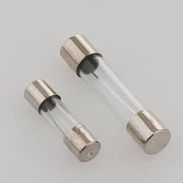 | box | 2
54 | Stopwatchساعة إستوب | For tuk tuk+ Motocycle | pcs | 2
55 | Flash deviceجهاز فلاش | Flash device for For tuk tuk+ Motocycle | pcs | 2
56 | led lamp لمبات بلف | tuk tuk+ Motocycle12volt | Dozen | 1
57 | Light switchمفتاح نور | tuk tuk + Motocycle | pcs | 4
58 | switchgear مجمع مفتاح كتلة | tuk tuk + Motocycle | pcs | 2
59 | Horns Key مفتاح بوري | right /left | pcs | 2
60 | Connecting wiresأسلاك توصيل | 2ml / 3ml | Roll | 2
61 | Benzine filterمصفي بنزين | tuk tuk + Motocycle | box | 2
62 | brake lining قماش فرامل | Front tuk tuk + Motocycle rear break bads set | set | 2
63 | Spark plugs بلكات | tuk tuk + Motocycle |  | set
Total Price VAT Inclusive

1-4- Solar System Requirements

# | Items | Specifications | Unit | QTY | Unit Cost in SDG or USD VAT Inclusive | Total cost in SDG or USD VAT Inclusive
1 | Medium size Needle-nose pliers | 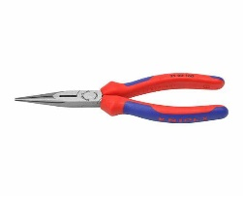 |  | 10
2 | Screwdriver size 12 طقم مفكات | 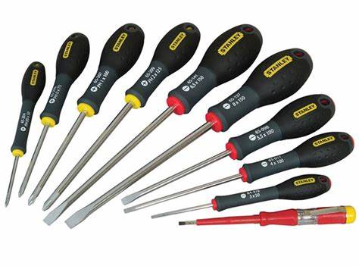 | set | 2
3 | Solar Inverter انفيرتر (محول) | 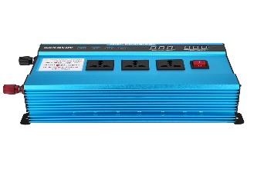 | KG | 3
4 | Battery بطارية |  | 100A | 3
5 | Solar energy slices شرائح طاقة شمشية | 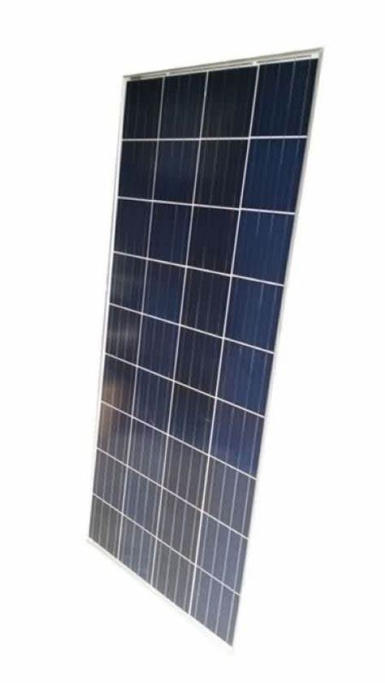 | 100W | 6
6 | Voltage regulator module منظم |  | 50A | 3
7 | سلك 1.5 wire | كيبلات الشرق oriental cables | Roll | 4
8 | سلك wire 2.5 | كيبلات الشرق oriental cables | Roll | 4
9 | 4 milli | كيبلات الشرق oriental cables | Roll | 3
10 | generator dashboard | 9 Line | pcs | 3
11 | شريط كهربائي electrical tape | Original | roll | 20
12 | bulb seat مقاعد لمبة | فاخرة good quality 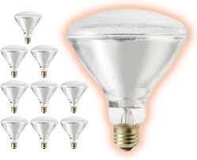 | pcs | 10
13 | لمبة bulb | قلووظ | pcs | 10
14 | Plastic boxs علب بلاستيك | Normal Plastic بلاستيك عادي |  | 10
15 | مفتاح واحد خط key one way line | تاوس Taos |  | 10
16 | spark plugs بلك | تاوس Taos |  | 10
Total Price VAT Inclusive

1-5- Electrical Maintenance

# | Items | Specifications | Unit | QTY | Unit Cost in SDG or USD VAT Inclusive | Total cost in SDG or USD VAT Inclusive
1 | Needle-nose pliers زردية اصلية |  |  | 15
2 | screwdriver kit of 10 | Medium size | Kit | 15
3 | 1.5 wire roll size لفة سلك فرادي سعودي1.5 |  | Roll | 4
4 | 2.5 Wire roll size  2.5 لفة سلك فرادي سعودي |  | Roll | 4
5 | Wire roll size 4 لفة سلك فرادي سعودي 4 ملي |  | Roll | 4
6 | طبلون 6 خط Dash board 6 line |  | pcs | 3
7 | electrical tape شريط كهرباء |  | pcs | 15
8 | bulb seat good quality مقعد لمبة فاخر |  | pcs | 20
9 | nine watt automatic bulb لمبة الية 9 واط |  | W | 20
10 | علبة بلاستيك plastic box |  | box | 20
11 | مفتاح 1 خط + بلك سعودي Key 1 Line + spark plugs |  | pcs | 15
12 | بلك 16 امبير سعودي spark plugs 16 Amp, Sudi saudi arabia or similar |  | pcs | 15
13 | مروحة سقف اورينت Orient Roof Fan or similar |  | pcs | 4
14 | جرس باب doorbell | Electric doorbell, medium size | pcs | 4
15 | مفتاح جرس bell key | Electric doorbell, medium size | pcs | 4
Total Price VAT Inclusive

IMPORTANT REMARKS

- You can use the above table OR you can print your quotation on your own letterhead.
- Your quotation shall be printed, signed and stamped.
- Do not forget to include your company name, address, contact details as well as your tax number.
- Prices must include VAT (in prices or in total).
- If different taxes & fees apply, please specify them all in your quotations and include them all.
- All bids submitted after that date will be rejected
- All interested and eligible firms are requested to submit their offers to the below mentioned address hard copy delivered to Gadarif Office – East Jobarab – Alriyada Street - Gadarif Sudan
- https://goo.gl/maps/ppyRwrzuUeCX6pVy6 or a soft copy to the following email address fatima.abdelgadir@nrc.no

- Please answer the questions:

Questions | Answers
What is the currency of the offer?
(SDG, USD, other…)
NRC can accept quote in USD or SDG, but supplier must choose and provide quotation in only one currency. In case a supplier provides quotes in both currency, only the USD quote will be considered.

If your offer is in USD => payment will be made by bank transfer.
- Do you have a USD account in Sudan?
- If YES, then in which bank. (Preferable)
- Do you have a USD account abroad? If YES, then in which bank.
(please provide bank details for each account)
Please confirm that the General Manager, CEO or owner of the company gives his consent to the mandatory Counter Terrorism check that will be conducted by NRC.
Thank you to provide a copy of the ID or Passport of the person.
Please confirm your prices include all taxes and fees (net prices) :
(if not, please explain and detail the taxes & fees)
What is warranty period and conditions for all items?
What's country of origin for all products?
What’s the delivery time of items? (in days)
Please confirm delivery locations in Gadarif, to NRC youth centre at umrakuba camp zone 4 .
Do you accept payment after delivery?
Payment will be within 20 working days after the delivery
What is the validity period of your offer?
(in days) – minimum 30 days

- Accepted methods for submission of quotation / offer:

We recommend you to fill up this Request for Quotation directly on your computer.

You can also print it and fill it up by hand if you have not access to a computer.

You can submit the price offer by using the table on page 1, or by using your own pro-forma document.
Your quotation / offer must be signed and stamped on all pages (including the present Request for Quotation

Do not forget to include all mandatory documents. Incomplete offers may not be considered.
IMPORTANT NOTE regarding USD quotes and payments:

- You must choose between quoting in USD or, quoting in SDG.
  - Do not provide quotes in both currencies. If you do so, only your quote in USD will be considered for assessment.
- If your quote is in USD, then you will be paid in USD.
  - You must be in capacity to accept the payment.
- NRC will favour payment in SDG
- In case, your company quoted in USD, in Sudan, in the same bank.
- NRC has USD bank accounts in :
  - Blue Nile Mashreg Bank
  - United Capital Bank.
- For payment within Sudan, you must have a bank account in one of the same bank as NRC.

We encourage you to contact us directly if you have questions or need clarifications before submitting your quotation.

- Your Company details:

Name of the company
Name of the owner(s)
Date of birth of the owner(s)
(mandatory for screening)
Address of the company

Name of contact person

Position

Email

Phone

Mandatory documents to attach to your quotation / offer:

Please check that you are providing all of the below mentioned documents:

Mandatory documents | Checked (Y/N)
Copy of renewed business license – Compulsory
Copy of VAT registration – Compulsory
Past contracts/ POs as proof of experience for similar contracts – Optional
NRC Request for Quotation (filled up, signed and stamped)
- You can use the RFQ table above
- Or any other format of your choice, but specifying all items in the RFQ list.
You must Sign and Stamp each page.

You can also attach additional documents such as photos, company profile, certify

- Payment information:

For payment by cheque, please indicate under which name NRC shall issue the cheque. You can write name in Arabic or in English.

Attention: if the name is not the company name, please provide a supporting letter to authorized NRC to issue the cheque under the name of the owner of the company or under the name of one of its employee. Contact us directly for more details.

For payment by bank transfer, please provide us with bank account information.

- Other information:

Payment will be made by bank transfer/cheque only.

All suppliers doing business with NRC should maintain high standards on ethical issues, respect and apply basic human and social rights, ensure non-exploitation of child labour, and give fair working conditions to their staff. NRC reserves the right to reject quotations provided by suppliers not meeting these standards.

Vendors doing business with NRC will be screened on anti-corruption due diligence before NRC confirms an order or contract.

NRC aims to purchase products and services that the minimum environmental impact. Environmental considerations form part of the NRC selection criteria, and NRC reserves the right to reject quotations provided by suppliers not meeting these standards.

NRC is obliged to ensure that its procurement decisions are clearly justified, documented, and keeping within the Donors mandatory principles. In that regard, full and on-the-spot access must be granted to representatives of NRC, the Donor or any organisation or person mandated by it, to premises belonging to NRC or its contractors. The right to access shall include all documents and information necessary to assess, or audit the implementation of the contract

NRC reserves the right to accept or reject the whole or part of your quotation based on the information provided. Incomplete quotations, which do not comply with our conditions, will not be considered.

Shortlisted suppliers may be required to submit samples of each item. Please be sure to have all samples available at short notice, and wait for a response from NRC if you have been shortlisted.

